Lab 3 – Basic Command Line
Name: QIMIN ZHU ID: 6888143
Do all problems by using the command line and paste screened capture of the results
- Switch from the GUI mode to command line mode.

- Go to /var directory and list all files and directories in the home directory, including all hidden files, but excluding the Download directory.
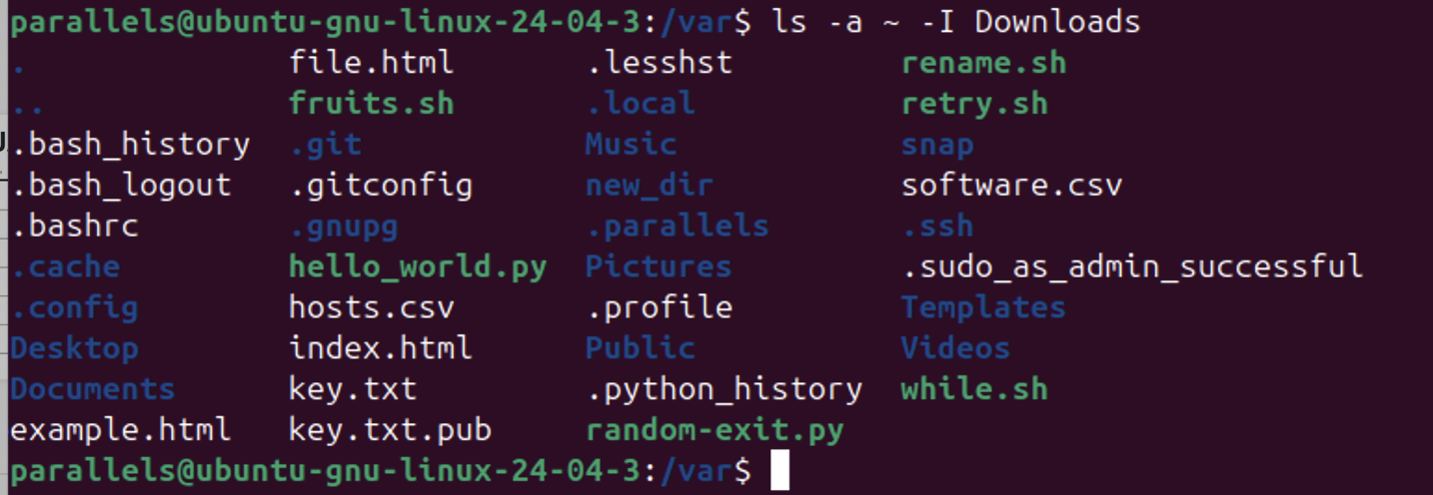

- Schedule shutdown time at 11:00 PM and show the message “It’s time to bed!”. Then, cancel the schedule.
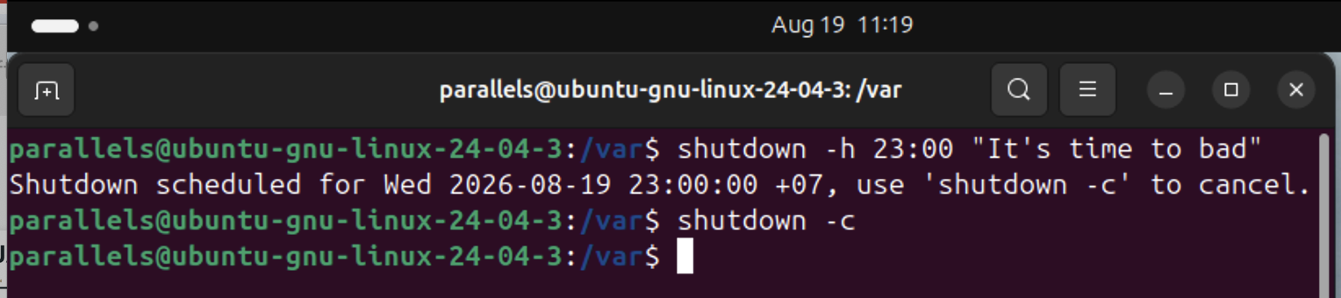

- Find out the location of the gcc utility.
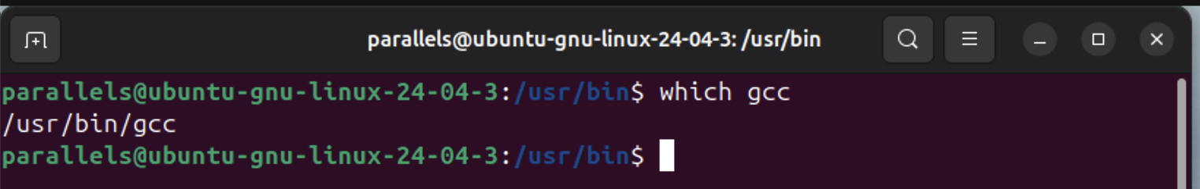

- Show details of the sudo command in the manual.
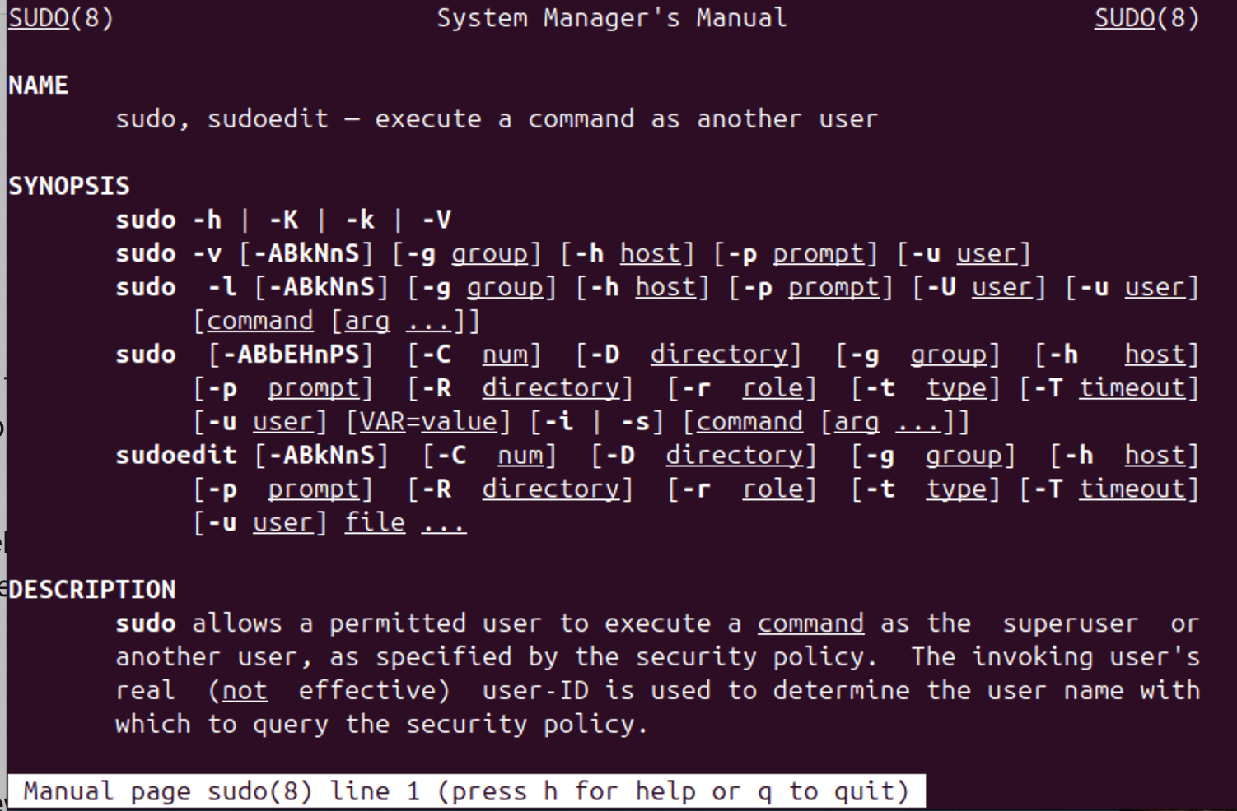

- Go to the home directory, then go to /usr/bin directory with the absolute pathname method. Then, go back to the home directory again by the shortcut method, i.e., using “-“ operator.
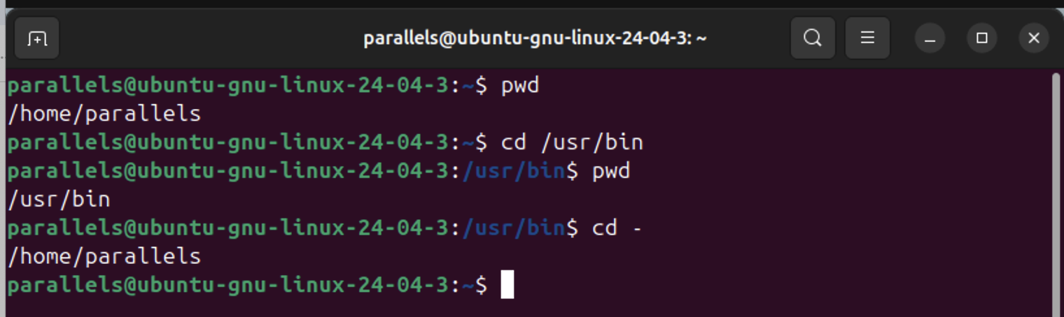

- Go to /etc directory with the relative pathname method, and display the present working directory. 